OPTIMIZING EMAIL-RELATED PRODUCTIVITY USING CONTEXTIFY

Gregor Leban, Marko Grobelnik
Jozef Stefan Institute
Jamova 39, 1000 Ljubljana, Slovenia
Tel: +386 1 4773127
e-mail: gregor.leban@ijs.si, marko.grobelnik@ijs.si

ABSTRACT

Contextify is a tool for maximizing user productivity by showing email-related contextual information. The contextual information is determined based on the currently selected email and includes related emails, people, attachments and web links. This content is displayed in a sidebar in Microsoft Outlook and in a special dialog that can display an extended context.

1 INTRODUCTION

Despite the popularity of numerous web services, emails still play a crucial role in today’s information exchange. It is very common for people to receive tens or even hundreds of emails per day. In this sea of information it is often difficult to stay organized and to find the right information when one needs it.

To help people perform mail-related tasks faster and with greater ease we developed Contextify. Contextify is an add-on for Microsoft Outlook. Its goal is to maximize user’s productivity by unobtrusively finding and showing the relevant contextual information for the currently selected email. The main functions of the add-on are displayed in two windows which will be described next.

2 CONTEXTIFY SIDEBAR

One way how Contextify displays the relevant contextual information is in a sidebar of Microsoft Outlook. The goal of the sidebar is to show important information related to the sender of an email being currently selected and shown within Outlook. This information is mainly gathered from past emails from this person but also from various online services such as Facebook, LinkedIn and Twitter.

An example of the sidebar is shown in Figure 1. The top of the sidebar displays the person's photo together with the relevant personal information collected from Outlook contacts and online social services (e.g. Facebook, LinkedIn). Other contextual information is organized into several tabs. In the first tab we show the list of recent emails from this person together with several email details (Figure 1.a). For emails that are a part of a thread, the whole thread can be brought into view by clicking on the email. Below the list of emails there is also a tag cloud of keywords that best describe the content of these emails. The second tab displays the list of exchanged attachments together with various details (Figure 1.b). Attachments that were exchanged several times, probably because being updated, are grouped together. They can be opened by clicking on the filename. The third tab lists the people who are participating in these emails (Figure 1.c) while the fourth tab displays the web links that were exchanged in the emails. The sidebar also provides searching capabilities where the context is determined based on the search terms and not the sender of the selected email. The found search terms are also highlighted for easier recognition. In the future we’ll add a tab with a summary with person’s appearance on various social services.

3 CONTEXTIFY DIALOG

An expanded context for the selected email can be displayed in the Contextify dialog. The goal of the dialog is to provide a visual display of the contextual information together with additional highlighting and filtering options. The context in this dialog consists of those emails where the participants (the sender and all the recipients) sufficiently match the participants in the currently selected email. The context is defined here as all emails sent to a similar social group. Such a definition of a context helps the user to see emails that are related to a particular aspect of his/her life.

An example of this dialog is shown in Figure 2. All emails that belong to the context are grouped into threads and displayed in the top left part of the dialog. Below the topic of each thread is a list of keywords that best describe the content of the thread. The bottom left part of the dialog shows a visualization of email activity for the computed context over time – each bar shows the number of emails
that were received in a particular time period. By selecting or unselecting specific bars the users can display only emails from a specific time period. The right side of the dialog shows the social network for the participants in the context. There is a directed edge between persons A and B if there is at least one email sent from A to B. The font size for nodes depends on how often the person is present in the emails – this helps quickly identifying the most relevant participants. Selecting a person in the graph also highlights emails sent by this person in the list of emails.
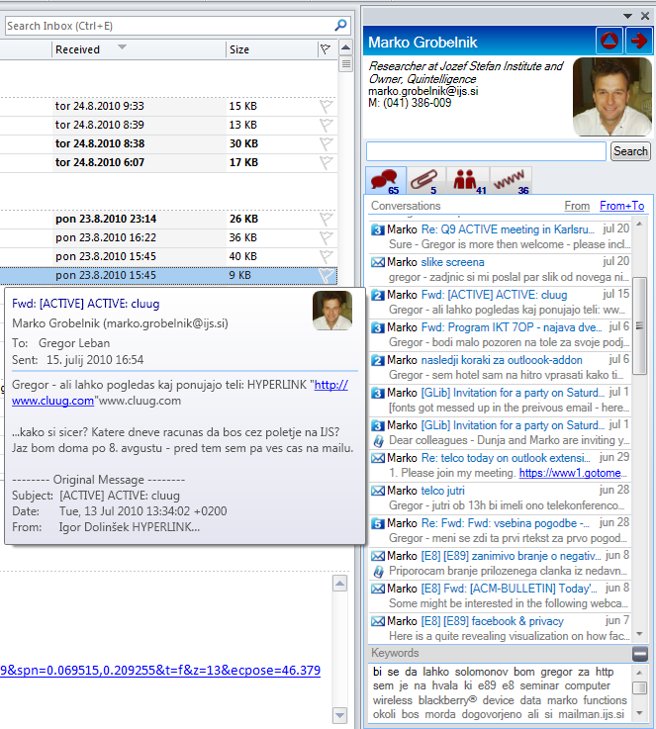 | 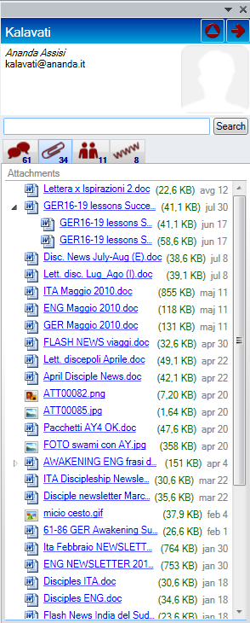 | 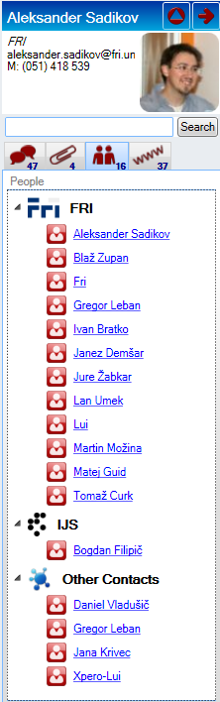
(a) | (b) | (c)

Figure 1. Information displayed in different tabs of the Contextify sidebar. The Email tab (a) shows recent emails from the selected contact, the Attachments tab (b) shows the exchanged files, and the People tab (c) shows the people included in the conversations.

4 CONTACT MANAGEMENT

Accessing and modifying information about contacts can be done in the Contact management dialog. Here, we can manually group different email addresses that represent the same person. In this way, when showing contextual information, emails from all person's email addresses will be displayed. By clicking the ''Import contact information'' button additional information about contacts can be automatically imported from Facebook, LinkedIn and Outlook contacts. The ''Cleanup contacts'' button provides a fast way to tidy-up contact names and to merge contacts which are likely to represent the same person. An example of the Contact management dialog is shown in Figure 3.

5 CONCLUSIONS AND FUTURE WORK

The goal of Contextify is to determine and show the relevant contextual information that should help the user to more efficiently perform his email-related tasks. We are currently working on text-mining algorithms to provide additional functionality such as email summarization, automatic categorization of emails into folders, improved extraction of information from email contents and more advanced contact management.

A video demonstration of the add-on can be seen at http://www.youtube.com/watch?v=hYpxhUvYM10
in lower resolution and in higher resolution at http://www.screencast.com/t/ODg5MzM1YWEt.
6 ACKNOWLEDGMENTS

This work was supported by the Slovenian Research Agency, the IST Programme of the EC under PASCAL2 (IST-NoE-216886) and ACTIVE (IST-2008-215040).

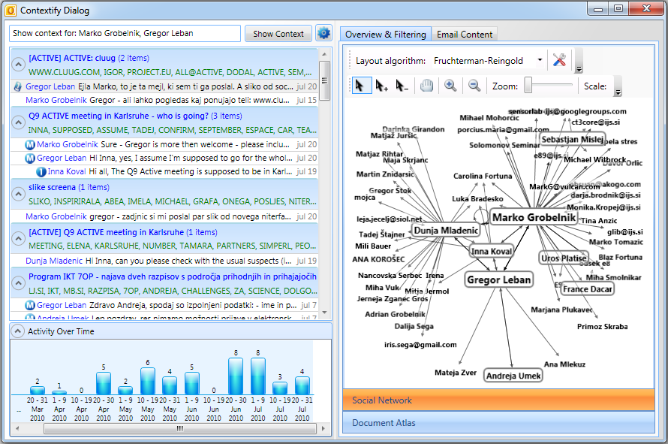
Figure 2. Contextify dialog displays an expanded version of the context.
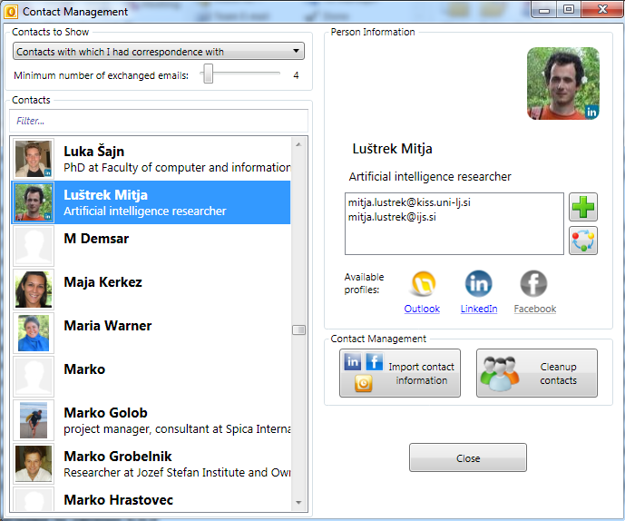
Figure 3. Contact management dialog displays information about the contacts collected from emails. Additional information about the contacts can be imported from social web-services such as Facebook and LinkedIn.

